

Program: Physics ATAR Unit 1 and Unit 2 2020

This document is offered as a guide only.

The program you have been issued references all objectives in the Curriculum Council syllabus. The syllabus may be easily downloaded from the Curriculum Council website: (http://wace1516.scsa.wa.edu.au/science/).

Topics | Time Allotment
1. Linear motion and force | 7 Weeks
2. Waves | 5 Weeks
3. Ionising radiation and nuclear reactions | 5 Weeks
4. Electrical circuits | 6 Weeks
5. Heating Processes | 5 weeks

TEXTBOOKS Pearson Physics 11
Exploring Physics (Year 11 ATAR) (2016): STAWA.
Physics Year 11 ATAR Course Study Guide (2014): Michael Lucarelli & Trevor Henderson.

Week | Content
1-7 | Linear motion and force  - distinguish between vector and scalar quantities, and add and subtract vectors in two dimensions  - uniformly accelerated motion is described in terms of relationships between measurable scalar and vector quantities, including displacement, speed, velocity and acceleration  This includes applying the relationships  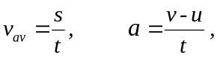  - representations, including graphs, vectors, and equations of motion, can be used qualitatively and quantitatively to describe and predict linear motion  - vertical motion is analysed by assuming the acceleration due to gravity is constant near Earth’s surface  - Newton’s three Laws of Motion describe the relationship between the force or forces acting on an object, modelled as a point mass, and the motion of the object due to the application of the force or forces  - free body diagrams show the forces and net force acting on objects, from descriptions of real-life situations involving forces acting in one or two dimensions  This includes applying the relationships  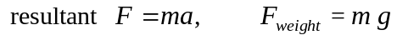  - momentum is a property of moving objects; it is conserved in a closed system and may be transferred from one object to another when a force acts over a time interval  This includes applying the relationships  - energy is conserved in isolated systems and is transferred from one object to another when a force is applied over a distance; this causes work to be done and changes the kinetic ( E_{k}) and/or potential (E_{p}) energy of objects  This includes applying the relationships  - collisions may be elastic and inelastic; kinetic energy is conserved in elastic collisions  This includes applying the relationship  - power is the rate of doing work or transferring energy  This includes applying the relationship  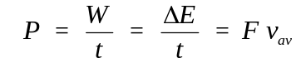  Science as a Human Endeavour  Safety for motorists and other road users has been substantially increased through application of Newton’s laws and conservation of momentum by the development and use of devices, including:  - helmets  - seatbelts  - crumple zones  - airbags  - safety barriers.
8-12 | Waves  - waves are periodic oscillations that transfer energy from one point to another  - mechanical waves transfer energy through a medium; longitudinal and transverse waves are distinguished by the relationship between the directions of oscillation of particles relative to the direction of the wave velocity  - waves may be represented by displacement/time and displacement/distance wave diagrams and described in terms of relationships between measurable quantities, including period, amplitude, wavelength, frequency and velocity  This includes applying the relationships  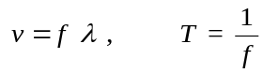  - the mechanical wave model can be used to explain phenomena related to reflection and refraction, including echoes and seismic phenomena  - the superposition of waves in a medium may lead to the formation of standing waves and interference phenomena, including standing waves in pipes and on stretched strings  This includes applying the relationships for  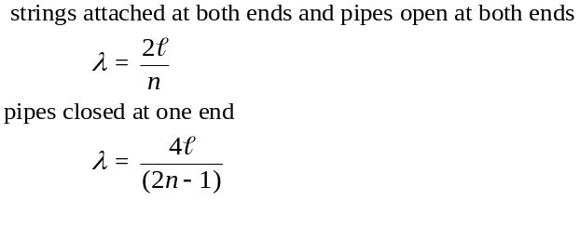  - a mechanical system resonates when it is driven at one of its natural frequencies of oscillation; energy is transferred efficiently into systems under these conditions  - the intensity of a wave decreases in an inverse square relationship with distance from a point source  This includes applying the relationship  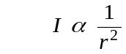  Science as a Human Endeavour  Application of the wave model has enabled the visualisation of imaging techniques. These can include:  - medical applications, such as ultrasound  - geophysical exploration, such as seismology.  Noise pollution comes from a variety of sources and is often amplified by walls, buildings and other built structures. Acoustic engineering, based on an understanding of the behaviour of sound waves, is used to reduce noise pollution. It focuses on absorbing sound waves or planning structures so that reflection and amplification do not occur.
13 | Assessment Free Week
14-15 | Semester 1 Examination
16-20 | Ionising radiation and nuclear reactions  - the nuclear model of the atom describes the atom as consisting of an extremely small nucleus which contains most of the atom’s mass, and is made up of positively charged protons and uncharged neutrons surrounded by negatively charged electrons  - nuclear stability is the result of the strong nuclear force which operates between nucleons over a very short distance and opposes the electrostatic repulsion between protons in the nucleus  - some nuclides are unstable and spontaneously decay, emitting alpha, beta (+/-) and/or gamma radiation over time until they become stable nuclides  - each species of radionuclide has a half-life which indicates the rate of decay  This includes applying the relationship  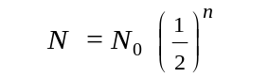  - alpha, beta and gamma radiation have different natures, properties and effects  - the measurement of absorbed dose and dose equivalence enables the analysis of health and environmental risks  This includes applying the relationships  - Einstein’s mass/energy relationship relates the binding energy of a nucleus to its mass defect  This includes applying the relationship    - Einstein’s mass/energy relationship also applies to all energy changes and enables the energy released in nuclear reactions to be determined from the mass change in the reaction  This includes applying the relationship    - alpha and beta decay are examples of spontaneous transmutation reactions, while artificial transmutation is a managed process that changes one nuclide into another  - neutron-induced nuclear fission is a reaction in which a heavy nuclide captures a neutron and then splits into smaller radioactive nuclides with the release of energy  - a fission chain reaction is a self-sustaining process that may be controlled to produce thermal energy, or uncontrolled to release energy explosively if its critical mass is exceeded  - nuclear fusion is a reaction in which light nuclides combine to form a heavier nuclide, with the release of energy  - more energy is released per nucleon in nuclear fusion than in nuclear fission because a greater percentage of the mass is transformed into energy  Science as a Human Endeavour  Qualitative and quantitative analyses of relative risk (including half-life, absorbed dose, dose equivalence) are used to inform community debates about the use of radioactive materials and nuclear reactions for a range of applications and purposes, including:  - radioisotopes are used as diagnostic tools and for tumour treatment in medicine  - nuclear power stations employ a variety of safety mechanisms to prevent nuclear accidents, including shielding, moderators, cooling systems and radiation monitors  - the management of nuclear waste is based on the knowledge of the behaviour of radiation.
21-26 | Electrical circuits  - there are two types of charge that exert forces on each other  - electric current is carried by discrete charge carriers; charge is conserved at all points in an electrical circuit  This includes applying the relationship  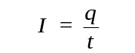  - energy is conserved in the energy transfers and transformations that occur in an electrical circuit  - the energy available to charges moving in an electrical circuit is measured using electric potential difference, which is defined as the change in potential energy per unit charge between two defined points in the circuit  This includes applying the relationship  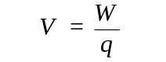  - energy is required to separate positive and negative charge carriers; charge separation produces an electrical potential difference that drives current in circuits  - power is the rate at which energy is transformed by a circuit component; power enables quantitative analysis of energy transformations in the circuit  This includes applying the relationship  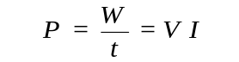  - resistance depends upon the nature and dimensions of a conductor  - resistance for ohmic and non-ohmic components is defined as the ratio of potential difference across the component to the current in the component  This includes applying the relationship  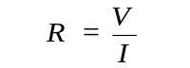  - circuit analysis and design involve calculation of the potential difference across the current in, and the power supplied to, components in series, parallel, and series/parallel circuits  This includes applying the relationships  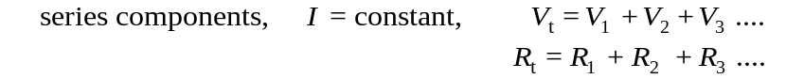  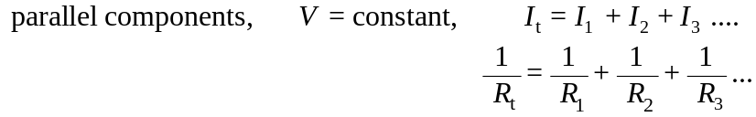  - there is an inherent danger involved with the use of electricity that can be reduced by using various safety devices, including fuses, residual current devices (RCD), circuit breakers, earth wires and double insulation  - electrical circuits enable electrical energy to be transferred and transformed into a range of other useful forms of energy, including thermal and kinetic energy, and light  Science as a Human Endeavour  The supply of electricity to homes has had an enormous impact on society and the environment. An understanding of electrical circuits informs the design of effective safety devices for the safe operation of:  - lighting  - power points  - stoves  - other household electrical devices.
27-31 | Heating processes  - the kinetic particle model describes matter as consisting of particles in constant motion, except at absolute zero  - all substances have internal energy due to the motion and separation of their particles  - temperature is a measure of the average kinetic energy of particles in a system  - provided a substance does not change state, its temperature change is proportional to the amount of energy added to or removed from the substance; the constant of proportionality describes the heat capacity of the substance  This includes applying the relationship    - change of state involves separating particles which exert attractive forces on each other; latent heat is the energy required to be added to or removed from a system to change the state of the system  This includes applying the relationship    - two systems in contact transfer energy between particles so that eventually the systems reach the same temperature; that is, they are in thermal equilibrium. This may involve changes of state as well as changes in temperature  - a system with thermal energy has the capacity to do mechanical work [to apply a force over a distance]; when work is done, the internal energy of the system changes  - because energy is conserved, the change in internal energy of a system is equal to the energy added by heating, or removed by cooling, plus the work done on or by the system  - heat transfer occurs between and within systems by conduction, convection and/or radiation  - energy transfers and transformations in mechanical systems always result in some heat loss to the environment, so that the usable energy is reduced and the system cannot be 100 percent efficient  This includes applying the relationship  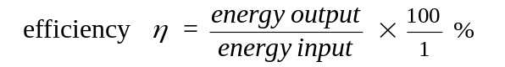  Science as a Human Endeavour  The development of heating technologies that use conduction, convection, radiation and latent heat have had, and continue to have, significant social, economic and environmental impacts. These technologies include:  - passive solar design for heating and cooling of buildings (21CLD principles)  - the development of the refrigerator over time  - the use of the sun for heating water  - engine cooling systems in cars.
32 | Assessment Free Week
33-34 | Semester 2 examination
35-38 | Physics ATAR Year 12 Unit 3 work commences (Vector Analysis, Parabolic and Projectile Motion)

